1. 
2. The last growth rate we talk about is **Exponential Growth** which is opposite of **Logarithmic Growth.**
3. So, the **Logarithmic curve slows down as the input size grows  
   whereas Exponential Curve grows faster and faster.  
   So, the algo that runs in Exponential time is not scalable at all.**
4. 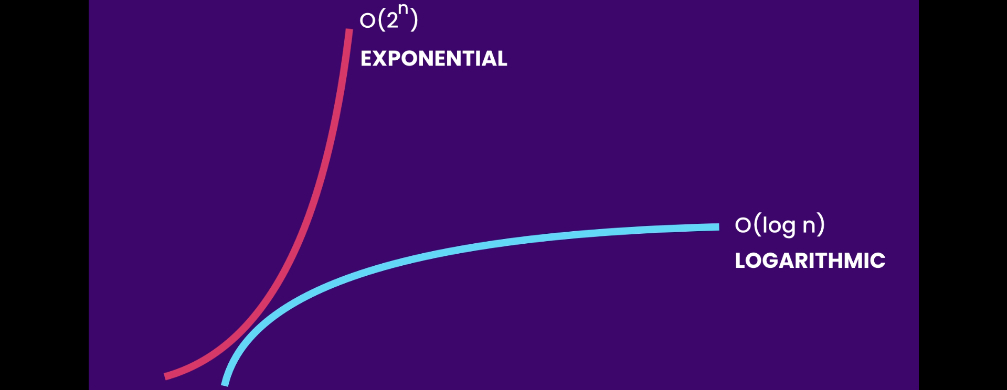
5. 